Step 1: Overview and Account Registration
Click here to get started: http://www.backgroundchecks.com/solutions/indianauniversity

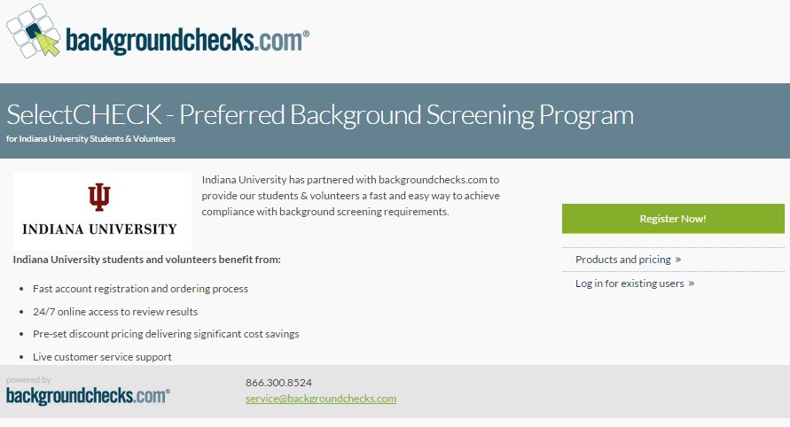
Here you will receive a general overview of the program, view products and pricing and most importantly, register your account.
Click Register Now! to get started

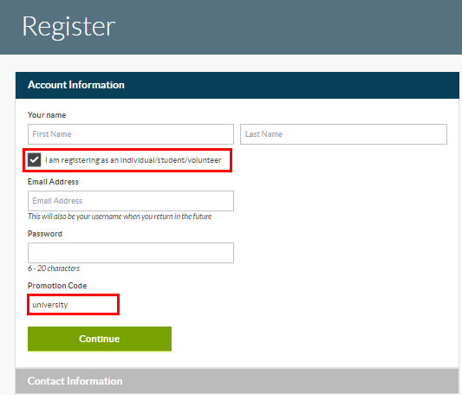
During registration process make sure to check the box confirming that you are registering as an individual/student/volunteer.

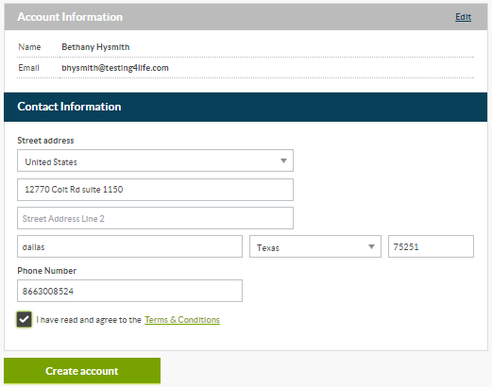
You’ll also notice that promo code: university is pre-populated to ensure account and screening compliance.

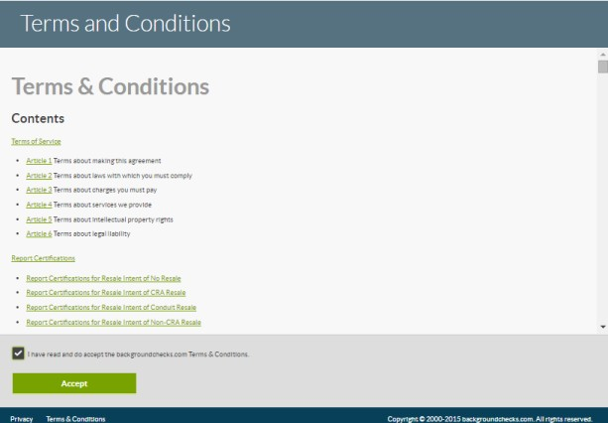
Continue with account registration by providing your current address, read and agree to the Terms & Conditions and create account.

Read and accept backgroundchecks.com Terms & Conditions.

You will also be presented with Indiana University’s Terms and Conditions.
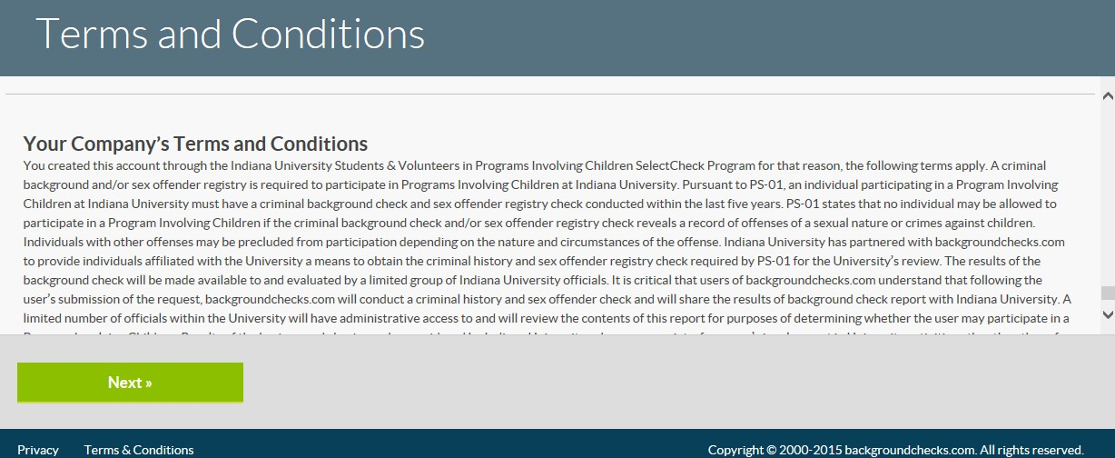

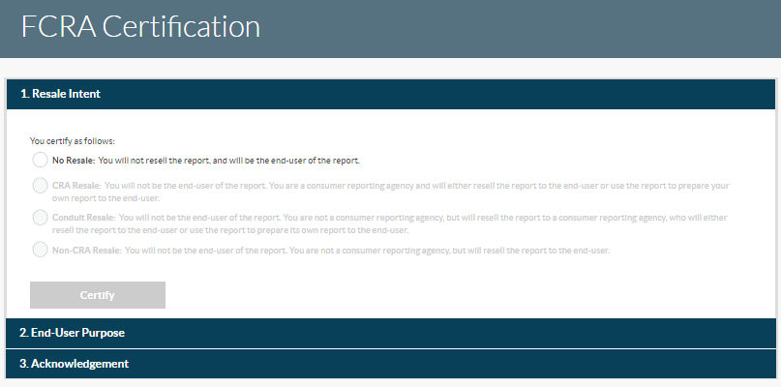
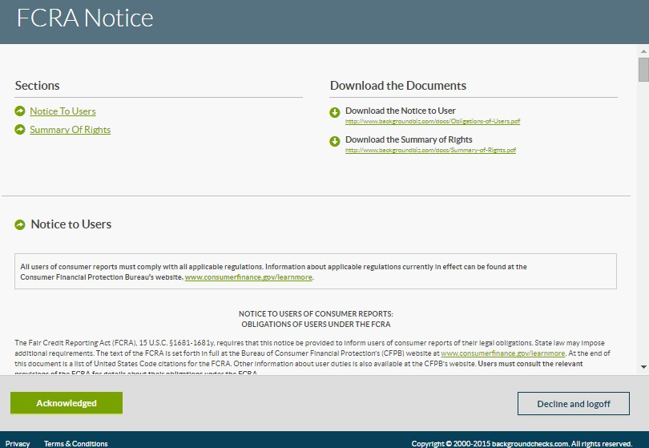
Complete FCRA Certification steps (tell us how and why you’re utilizing our services to obtain your report).

Acknowledge FCRA Notices to complete the account registration process.

Step 2: Order your report
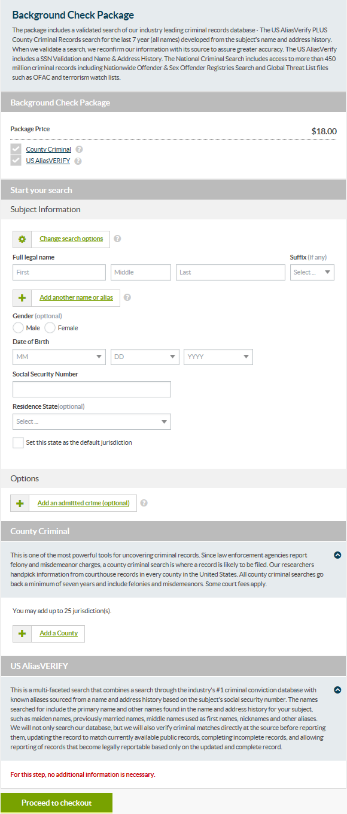
Upon successful account registration, you can order your report. Your account has been configured to immediately display the Indiana University Background Check Package for Students & Volunteers.

Simply provide your full name, date of birth, SSN and residence state to start the package order.

Our system will develop known alias names and addresses where you have lived for the past 7 years.

This information will be used to conduct the appropriate background checks on all alias names and in areas where you have lived for the past 7 years.

Click Proceed to checkout to confirm your order.

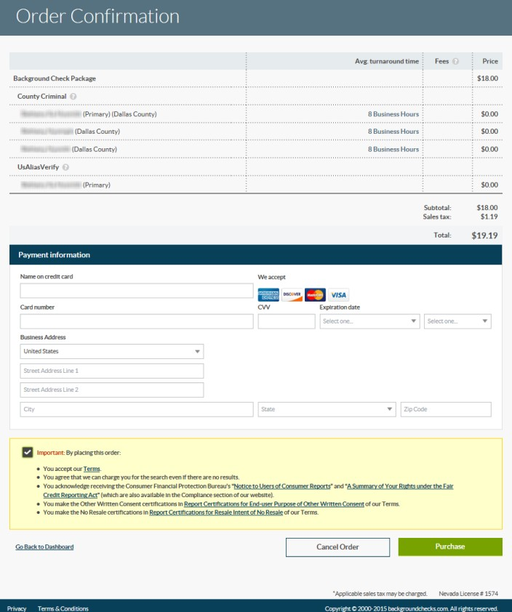
Confirm order details, enter payment information, agree and acknowledge terms & conditions and click Purchase to complete your order.

Step 3: Reports and Certificates
Once the order is placed, you will see the report in the Manage Reports Inbox.

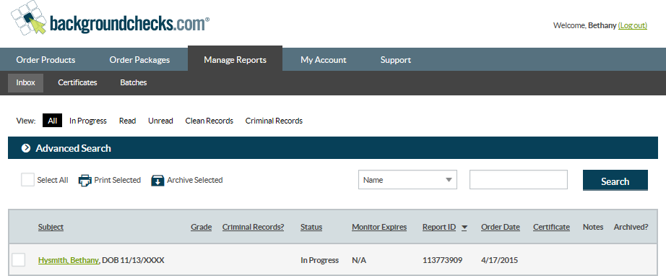
Initially, your report will have an In Progress status. Your report may take up to 1-3 business days to complete.

You can view the report while it is In Progress and when it is Complete by clicking on your name in the Inbox.

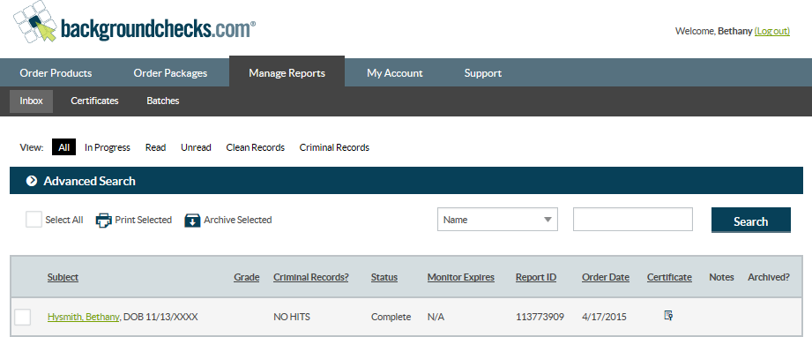
Once your report is Complete, a Certificate will enable confirming compliance with the background screening process.

Access the Certificate from the Inbox or your completed report.

