CURRICULUM INTERNATIONALIZATION..................................................................................................................

Virtual Exchange as a Form of Curriculum Internationalization
Facilitating Global Learning on an Urban Campus

By Leslie A. Bozeman and Yao-Yi Fu

INDIANA UNIVERSITY-PURDUE
UNIVERSITY Indianapolis (IUPUI), Indiana's premier urban public research university, is dedicated to graduating students who under­ stand and function well in a globally inter­ dependent world. The university strives to produce students who meet certain interna­ tional learning goals, including knowledge of the broader world; awareness of the cultures, language, and history of at least one country beyond the United States; recognition of the ways "the global is reflected in the local" within the United States, and an understanding of the global context of their profession.
Some IUPUI students will work toward these goals through participation in study abroad. Others will work toward them through the courses in which they are enrolled on campus-especially students who are not well-positioned to travel abroad because of financial constraints, work, family, or other responsibilities and circumstances. Because of this, curriculum internationalization, "the incorporation of an international and intercultural dimension into the content of the curriculum as well as the teaching and learning arrangements and support services of a program of study" (Leask, 2009), is an essential strategy for providing students with the global perspectives today's world requires. IUPUI has been facilitating global learning through curriculum internationalization and using virtual exchange as a specific tool for more than a decade. Two methods of virtual exchange in particular that IUPUI has employed are international videoconferencingthrough its Global Crossroads Classroom and social media posting through the Global Classmates feature oflndiana University's (IU) learning manage­
ment system, CourseNetworking.
The Global Crossroads (GXR) Classroom is a state-of-the-art videoconferencingfacility available to IUPUI faculty for use in courses, lectures, or meetings. IUPUI has used inter­ national videoconferencing to facilitate global learning for students as well as to advance long­ term international campus partnerships. To date, the GXR Classroom has been used to

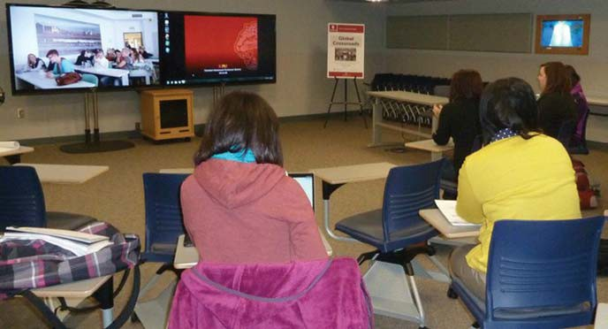
facilitate on-going courses and one-time events that focus on global learning in Colombia, Gaza, Israel, Kenya, Mexico, Slovenia, Switzerland, and Turkey. Close to 600 students, at IUPUI and around the world, have engaged in global learning through the GXR Classroom.
CourseNetworking (CN) is an "online learning and collaborations environment" that connects teachers and students from IU with others around the world based on shared interests and class subjects. It was established in 2011 with funding from IU, and the IUPUI CyberLab is the technology research and development lab for the CN. In a CN course, members can create posts and make them visible to their own class as well as students and instructors around the world, or view and reflect on posts from those students and instructors. As of today, the CN has more than 80,000 users in approximately 140 countries.

Bridging the Gap
Several courses at IUPUI have employed virtual exchange, including the School of Education's American Culture and Education course, taught by Dr. Deborah Keller and the Office of International Affairs' offer­ ing, the Gaza Visioning Project, taught by IUPUI Director of International Partnerships Dr. Ian McIntosh and Gaza University Professor Dr. Jamil Alfaleet. The American Culture and Education course features a once-per-semester,

bi-national conversation between students and instructors at IUPUI and the Universidad Aut6noma del Estado de Hidalgo in Pachuca, Mexico. The students engage in a cross-cultural experience in which they discuss their respec­ tive countries and education systems.
The Gaza Visioning Project employed the GXR as a "peace incubator" for their 2012 Global Visioning Project. This was a semester-long videoconference class link­ ing IUPUI and Gaza University, with the aim of developing a model for building ties of friendship and cooperation that might facilitate peacebuilding among the student population of Gaza. Rather than replicate a study abroad experience, the goal of the project was "to explore potential use of the university classroom as a tool for intentional peacebuilding" (McIntosh and Alafeet, 2014). IUPUI's Department of Physical Education and Tourism Management's Global Tourism Seminar, a senior-level, required course, has deeply integrated both the GXR and the Global Classmates Feature into its course design. This course, taught by Dr. Yao-Yi Fu since 2013, provides students at IUPUI and the University of Primorska in Slovenia, with an international perspective on the key issues facing global tourism. Dr. Fu estimates that 96 IUPUI students and 80 Slovenian students have been impacted by this course component. Students in this course participate in live class

20 //fNETW RKER www.iie.org/iienetworker

discussions twice a week with a group of tour­ ism students and faculty. The main goals for the course are to learn about global tourism from different global and cultural perspec­ tives, to provide students with an interna­ tional experience without traveling abroad, and to further develop students' intercultural competence.
The Global Tourism Seminar involves two weekly videoconferences, during which students from both countries discuss topics related to global tourism. To extend interac­ tions beyond classroom time, the instructors in both countries encourage students to use the CN Global Classmates feature to create and respond to posts, and share photos and videos. In addition to matters of tourism, students are instructed to share information that promotes mutual understanding of each other's country and culture. Compared to the classroom setting, the cultural exchange via the CN provides students a more casual envi­ ronment to learn and connect on a personal level. For example, students post pictures and videos of their hometowns, and discuss hob­ bies, leisure activities, holidays, college life, travel experiences, and their career aspirations in the tourism industry. These discussions promote cross-cultural understanding.
In addition to using the CN, the American and Slovenian students in the Global Tourism Seminar use Skype or other social media platforms to conduct formal interviews with one another regarding tourism and cul­ tural issues. All of these class activities are designed to provide students with a variety of formal and informal ways to connect and engage in intercultural learning.

Finding Practical Uses
At the end of the semester, students are asked to reflect on their virtual global experience using a conceptual framework based on knowl­ edge, skills, and attitudes (KSAs) that represent intercultural competence (Deardorff, 2008). They are measured both quantitatively and qualitatively by collecting data from students' learning reflections and by gathering direct evidence of student performance as demon­ strated in their paired interview assignments and messages posted on the CN site.
Students' interactions via videoconferences and the CN site, as well as their comments on the reflection assignment, indicate that the virtual global experience is fruitful as shown
in these student remarks: "I think overall our class has learned a lot about a different culture and through our differences; we have created a bond through learning from each other. I believe we will continue to build upon this bond and will continue our global dialogue long after this course is over." "I feel thankful that I got the opportunity to experience such a cool connection between us and students across the world. It was awesome. I loved that even though we were halfway across the world from each other, we all still had this core center that embodies the love of tourism."
The virtual connection helped students expand their intercultural understanding without leaving home as evidenced in this comment: "I love to have knowledge about different cultures and their histories, but I haven't had many experiences with people. I'm so busy in my own life with studies and work that I don't always put my mind to learning more about people and their cultures. This experience has brought this more to my atten­ tion. I hope that in the future I will be able to open up more to new experiences and people." Curriculum internationalization through virtual exchange provides a valuable oppor­ tunity for student and faculty development. It is especially beneficial for a demographic of students who may not be readily able to travel abroad due to life's circumstances. Faculty benefits can include enhancing their scope of disciplinary knowledge, widening their
pool of research collaborators, and enriching their own professional interactions through intercultural interaction.
To increase use of virtual exchange as a global learning strategy at IUPUI, Director of Curriculum Internationalization Dr. Leslie Bozeman is working to raise awareness of the GXR through inclusion of this space in an IV-initiated faculty fellows program designed to inform faculty use of interactive classrooms. She is also encouraging use of both the GXR and the Global Classmates feature of the CN through proactive discussions with faculty, a coordinated marketing campaign for the GXR, and collaboration with the IUPUI CyberLab to
assess, track, and enhance faculty and student use of the Global Classmates feature. ■
Leslie A. Bozeman is director of curriculum internationalization at Indiana University­ Purdue University Indianapolis (IUPUI); Yao-Yi Fu is associate professor of tourism, convention, and event management at IUPUI.

REFERENCES
Deardorff, D. (2008). lntercultural competence: A definition, model, and implications for study abroad. In V.Savicki (Ed.), Developing intercultural competence and trans­ formation: Theory, research, and application in inter­ national education (pp. 297-312). Sterling, VA: Stylus.
CourseNetworking. 2016, April 16. Retrieved from https://www.thecn.com/
Leask, B. (2015). Internationalizing the Curriculum. New York: Routledge.
McIntosh, Ian S. and Alfaleet, Jamil (2014). "The Classroom as a Peace Incubator: A US-Gaza Case Study,' Peace and Conflict Studies: Vol. 21: No. 2, Article 5.

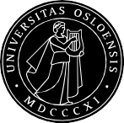
//fNETW RKER 21
UiO : International Summer School
University of Oslo, Norway

Come to Norway - Experience the World!
An Academic Experience: A Cultural Experience:
- Bachelor's courses • Weekend excursions
•
•
Master's courses Norwegian language courses (all levels)
- International forum
- Cultural evenings
Join over 550 students from more than 90 countries at ISS!
For more information: www.uio.no/summerschool • iss@stolaf.edu • (800) 639-0058

